G Dungeon

It’s a dungeon scroller in wich the objective is to kill as many bosses as possible. To do so, you will need to go thru a set of rooms that are always set up as shown in the drawing bellow. In this rooms, the player will find enemies to fight and treasures to use in the dungeon (such as better weapons or healing potions) and will eventually find the boss. Defeating the boss will mean getting to the next level and being gifted with a safe room in wich the player will heal.

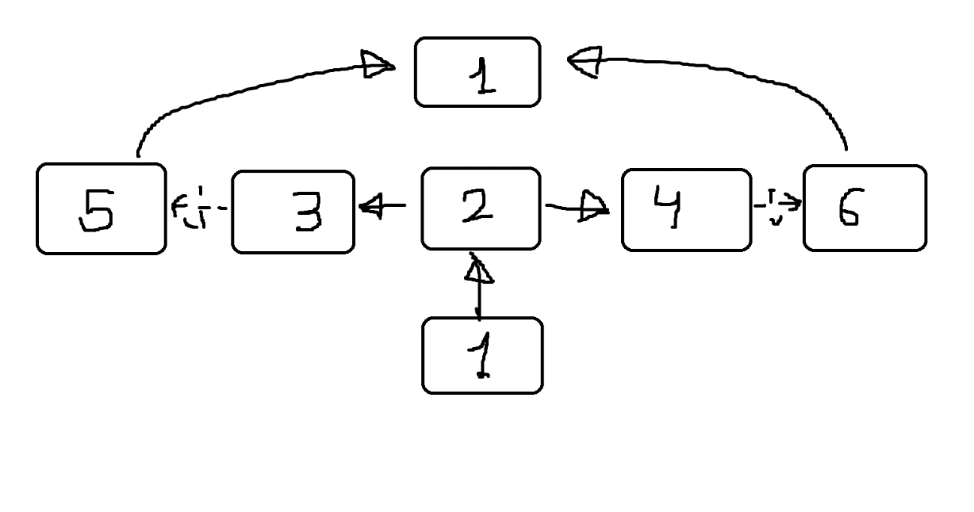

* Room explanation:

1. Safe room

* This is the first room you will see in every level.
* When you enter this room, you will heal to max HP (20HP).
* Once you leave this room, you cannot go back.

1. Enemy room

* This room will either have 1, 2, or 3 enemies.

1. Random room

* This room will either have 1, 2, or 3 enemies, or a treasure chest (without repeating the number of enemies of room 2)

1. Random room .2

* This room will either have 1, 2, or 3 enemies, or a treasure chest (without repeating the number of enemies of room 2 or 3 (and if room 3 was a chest room, this room can’t be a chest room too)).

1. Boss room

* This room has a 50% chance of appearing, and if it does appear, it will have the level boss in it.

1. Boss room .2

* This room has a 50% chance of appearing (either this room appears or room 5 appears, both can’t appear, but 1 always does), and if it does appear, it will have the level boss in it.
* Combat explanation:
* Combat is turn based, and the order of the turns is decided by the speed stat (the player always has a speed of 3 and different enemies have different speeds that will also vary depending on the weapon they are using).
* Once the order is decided, the attacks happen 1 by 1 and the damage is decided by the attack stat of the attacker (for the player it depends on the weapon they decide to use), and when the player attacks, depending on the weapon the player decides to use and the weapon the victim of the attack has, the attack will be very effective (x2 damage), normal, or weak (half the damage).
* While in combat, the player may choose to use a potion in staid of attacking, getting rid of one of his potions and healing his HP up to the maximum (20 HP).
* Treasures:
* While in the dungeon, the player may find treasures that will help him getting thru the level. These treasures can be found in two places, treasure rooms and boss rooms (after defeating the boss), and they will be either a random weapon with up to two more damage than the old weapon, or a potion.
* Bosses:
* Combat against the bosses will develop in the same way as against the rest of the enemies (except the player won’t need to select a target because there is only one available).
* The bosses available are a unicorn, a bear, and a dragon, and they will appear in this order.
* Commands:
* next --> go to the next room (only available in rooms 5, 6 and 1).
* right --> go right (only available in rooms 2, 3 and 4).
* left --> go left (only available in rooms 2, 3 and 4).
* inventory --> shows your inventory (power of weapons and number of potions).
* HP --> checks your HP.
* potion --> uses a potion to restore your HP.
* commands --> shows the commands.
* exit --> ends the game.
* Difficulty progression:
* To keep the game interesting even when the player keeps upgrading his weapons, every time a boss is defeated, the enemies will upgrade one of their stats by 1, making it so the player always has a hard time, and it doesn’t get boring.
* End game:
* There is not a way to beat the game as it is endless. Every time you beat a boss, a new level will be created so the challenge can continue, so the objective is to beat as many bosses as possible.